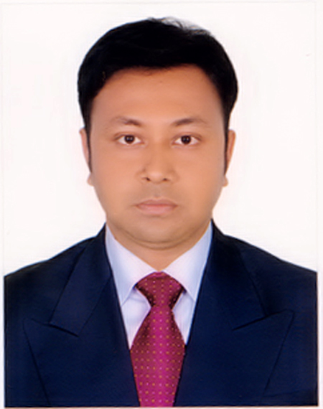
RESUME
OF
Tanvir Ahmed

Mailing Address:
C/O Akter Hossen.
348/3, Munshipara, Kuadanga, Gopalganj, Dahka.
Mobile: 01938684036
Email: tanvirus777@gmail.com

Career Objective:

To succeed in an environment of growth and excellence and earn a job which provides me satisfaction and self development and help me to achieve organizational goal.

Academic Qualification:

Masters of Business Administration:
Name of Institute : Govt. Bangabandhu College Gopalganj.
Passing Year : 2017
Major : Accounting
Result : GPA- 2.75 (out of 4)
University : National University

Bachelor of Business Administration:
Name of Institute : Govt. Bangabandhu College Gopalganj.
Passing Year : 2015
Major : Accounting
Result : GPA-3.10 (out of 4)
University : National University
Higher Secondary Certificate (HSC):
Name of Institute : Govt. Bangabandhu College, Gopalganj.
Passing Year : 2010
Group : Commerce
Result : GPA-3.60
Board : Dhaka
Secondary School Certificate (SSC):
Name of Institute : Haji N. S. Memorial High School, Gopalganj.
Passing Year : 2008
Group : Commerce
Result : GPA-4.50
Board : Dhaka

Computer Skill:
- Microsoft Word, Excel, Power point, Mailing, & Internet Browsing.

Language Efficiency:
- Bengali : Reading Writing, Speaking & Listening Excellent.
- English : Reading Writing, Speaking & Listening Well.

Personal Strength:
- Believing thyself and being positive.
- Ability to work under pressure and fulfill.
- Ability to work in term and maintain effective communication.
- Willingness to accept responsibility and perform accordingly.
Experience :
1.Executive (Branch incharge), Rangs Motors Ltd, Satkhira.
Responsible for sales and marketing ( 4 wheeler Mahindra & Mahindra)
Duration : September 16, 2017 to October 15, 2019.
2.Executive (Branch incharge), Rangs Motors Ltd, Khulna.
Responsible for sales and marketing ( 3 & 4 wheeler Mahindra & Mahindra)
Duration : October 16, 2019 to present.
Training :
1. Sales and Marketing strategy in super competetive global market.
2. Customer psychology to buy a product.
3. How to achieve Customer centricity.
4. Branch management skill.
Prefer Job sector :
Sales and Marketing, Business Development, Relation & Network Development
Dealer and Agent supervise, Supervising given Territory. Any type of
responsibilities in automobile sales and marketing sector.
Personal Information:

Name :Tanvir Ahmed.
Father Name : Akter Hossen.
Mothers Name : Farida Begum
Date of Birth : 08-03-1992
Nationality : Bangladeshi by birth
Religion : Islam
Marital Status : Married
Gender : Male
Permanent Address:

348/3,Munshipara, Kuadanga, Gopalganj, Dahka.

I hereby assure that the information mentioned above is all true and accurate. I am bound to take all responsibilities made for any mistakes regarding this information. If need any further information, I will provide them based on requirements.
Signature & Date

(Tanvir Ahmed)

Date:

